1. Project Overview
Title: LDU Factorization using Elimination Matrices
Courses: Introduction to computer
Team: Group no -5
Team Members- 1. Priya Saini
2. Vishal bhardwaj
3. Ritesh Jha
4. Yash yadav

Objective:
The LDU Factorization web application allows users to input an n×n matrix and perform LDU (Lower Diagonal-Upper) decomposition. The application breaks down a matrix into three distinct components:
• L (Lower triangular matrix)
• D (Diagonal matrix)
• U (Upper triangular matrix)
The application displays intermediate steps and the final result of the LDU factorization, making the process transparent and easy to follow for users.
2. User Interface
The interface consists of the following sections:
• Navbar: A simple navbar that links to the home page.
• Matrix Size Input:
- Users can specify the size of the matrix (n) using a numeric input. The default size is set to 3, but the user can change it to any positive integer.
- A button to trigger the matrix generation based on the specified size.

• Matrix Input Grid:
- After specifying the matrix size, an interactive grid of input fields is dynamically created where users can input their matrix values.
• Factorize Button:
- Once the matrix is filled, a button triggers the LDU factorization, and the application performs the decomposition.
• Output Display:

- After the factorization is complete, the results (along with the intermediate steps) are displayed. This includes the L, D, and U matrices, as well as the calculations performed during the process.
2. Visual Design
The visual design focuses on a clean and modern user interface, with a few key design elements:
• Background:
- A gradient background gives the interface a soft, visually appealing look, with dark and light tones.
• Container:
- The matrix input area and the results are enclosed within a centrally-aligned container, which provides a structured and organized appearance.
• Buttons:

- The buttons are styled to be inviting and interactive, with hover effects to provide visual feedback to the user.
• Matrix Display:

- The matrix is displayed in a grid format, where each value is neatly aligned within a cell. Cells are styled to make them easily readable.
• Responsive Design:

- The layout adjusts automatically to fit smaller screens (e.g., mobile devices), ensuring that the application is accessible on various devices.
3. Functionality
The main functionality revolves around matrix input, LDU factorization, and displaying the steps and results. Here’s a breakdown of how it works:
• Matrix Generation:
- The user inputs the size of the matrix, and the application generates an input grid with the corresponding number of fields. Each field represents a matrix element, initially set to 0. Users can fill in their values
. • LDU Factorization:
- After filling in the matrix, the user clicks the "Factorize" button to perform LDU decomposition.
- The application decomposes the matrix A into three matrices:
  - L (Lower triangular)
  - D (Diagonal)
  - U (Upper triangular)
- It follows a step-by-step process to compute the values of L, D, and U. Intermediate results are displayed after each step.
• Step-by-Step Process:
- Each step of the factorization is displayed to the user, showing the operations performed to compute the corresponding entries in the L, D, and U matrices.

• Final Results:
- After all steps are completed, the final matrices L, D, and U are displayed, providing the user with a complete breakdown of the factorization.
4. Key Features
- Dynamic Matrix Generation: Users can input matrices of any size by adjusting the size input field, and the matrix grid will automatically adjust accordingly.
- Interactive Factorization: The factorization is interactive and shows all intermediate steps, giving users an educational insight into how LDU factorization works.
- Clear and Detailed Output: The results are presented in a user-friendly manner, with matrices displayed clearly and intermediate steps broken down in a way that is easy to follow
- Responsive Design: The application adapts to different screen sizes, making it usable on both desktops and mobile devices.
5. Technologies Used
HTML: To structure the content and create the interactive elements, such as buttons and input fields.
CSS: For styling the user interface, including responsive design, gradients, and hover effects.
JavaScript: To handle the logic for matrix generation, LDU factorization, and displaying the intermediate steps and results.
6. Screenshots of Project Development
Google Meeting Screenshots:
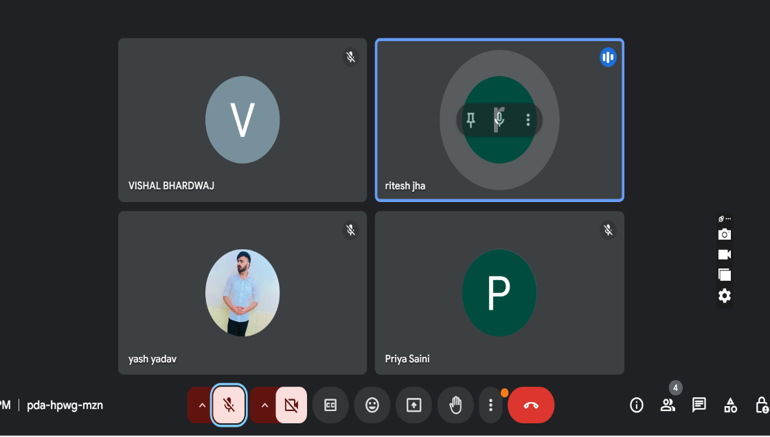
Sample Screenshot-
Email Conversations: Include email screenshots to document project-related discussions.
7. Conclusion
This web application is a useful tool for learning and visualizing LDU factorization. It allows users to input any square matrix, perform the factorization, and understand the step-by-step process involved in decomposing the matrix into its L, D, and U components. With its user-friendly design and interactive nature, the tool offers an engaging way to explore matrix decompositions.
8. Refrences
- Textbooks and online resources on LDU factorization.
- GitHub repository and documentation standards.

